COMPLETE REPORT: K-Means Clustering Analysis for At-Risk Student Identification
Course Assignment | Deadline: 7th May 2026

EXECUTIVE SUMMARY
This report presents a K-means clustering analysis of 943 students to identify at-risk individuals based on five behavioral and academic risk factors: Tardies, Absences, Suspension, Expulsion, and Arrest. Following the CRISP-DM methodology, the analysis successfully identified five distinct risk profiles ranging from Low Risk (46.6% of students) to Critical Risk (4.9% of students). The clustering model demonstrated good quality with a Davies-Bouldin index of -1.009 and successfully isolated 46 students requiring immediate intervention. Tiered recommendations are provided based on cluster membership.

PHASE 1: BUSINESS UNDERSTANDING
1.1 Problem Statement
The school needs to identify students who are at risk of negative educational outcomes (academic failure, dropout, legal involvement) based on observable behavioral indicators.
1.2 Objectives
Objective | Success Criteria
Segment students into risk-based clusters | 3-6 interpretable clusters
Identify high-risk students | Small cluster with extreme values (3-8% of population)
Evaluate clustering quality | Davies-Bouldin < 1.5
Provide actionable recommendations | Tiered interventions per cluster
1.3 Data Requirements
- Target variable: None (unsupervised learning)
- Features: Tardies, Absences, Suspension, Expulsion, Arrest
- Excluded: Student_ID, Names, Gender, Grade

PHASE 2: DATA UNDERSTANDING
2.1 Dataset Overview
Attribute | Type | Range | Description
Student_ID | Nominal | 1-943 | Unique identifier
First/Last Name | Nominal | - | Student names
Gender | Binary | 0=Female, 1=Male | Demographic (excluded)
Grade | Ordinal | 9-12 | Grade level (excluded)
Tardies | Integer | 0-11 | Times late to class
Absences | Integer | 0-12 | Days absent
Suspension | Binary | 0/1 | Ever suspended
Expulsion | Binary | 0/1 | Ever expelled
Arrest | Integer | 0-4 | Times arrested
2.2 Data Characteristics
- Total Records: 943
- Missing Values: None
- Feature Scales: Vary significantly (0-12 vs 0-4 binary)
- Normalization Required: Yes (z-score)

PHASE 3: DATA PREPARATION
3.1 Attribute Selection
Selected for clustering: Tardies, Absences, Suspension, Expulsion, Arrest
Excluded attributes:
- Student_ID, First_Name, Last_Name (identifiers only)
- Gender, Grade (not relevant to risk analysis)
3.2 Data Transformation (Z-Score Normalization)
Applied to ensure all features contribute equally:
Formula | Purpose
z = (x - μ) / σ | Transform to mean=0, std=1
Why required:
- Raw Tardies range: 0-11
- Raw Arrest range: 0-4
- Without normalization, Tardies would dominate distance calculations

PHASE 4: MODELING (K-MEANS CLUSTERING)
4.1 Optimal K Selection (Elbow Method)
K-means was executed for K=2 through K=8:
K | Cluster Sizes | Smallest | Largest | Imbalance
2 | 564, 379 | 379 | 564 | 1.49:1
3 | 537, 259, 147 | 147 | 537 | 3.65:1
4 | 532, 251, 121, 39 | 39 | 532 | 13.64:1
5 | 439, 188, 152, 118, 46 | 46 | 439 | 9.54:1
6 | 387, 153, 129, 121, 114, 39 | 39 | 387 | 9.92:1
7 | 372, 130, 125, 124, 118, 45, 29 | 29 | 372 | 12.83:1
8 | 387, 121, 115, 113, 90, 46, 39, 32 | 32 | 387 | 12.09:1
Decision: K=5 selected as optimal
- Produces meaningful 46-student critical risk cluster (4.9%)
- Avoids clusters <40 students that appear at K=6,7,8
- Maintains interpretable risk differentiation
4.2 Final K-Means Configuration
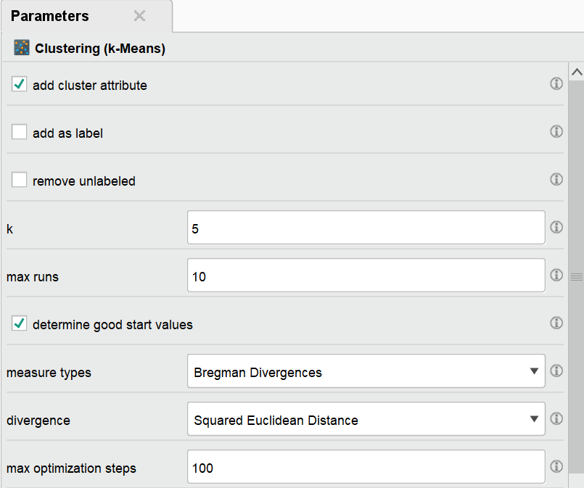

PHASE 5: EVALUATION
5.1 Clustering Quality Metrics
Performance Vector Results (K=5):
Metric | Value | Interpretation
Avg. within centroid distance (overall) | -1.337 | Moderate cohesion
Davies-Bouldin Index | -1.009 | Good separation
Cluster 3 (Low Risk) | -0.554 | Tightest cluster
Cluster 4 (Critical Risk) | -3.055 | Most dispersed
Cluster-wise Performance:
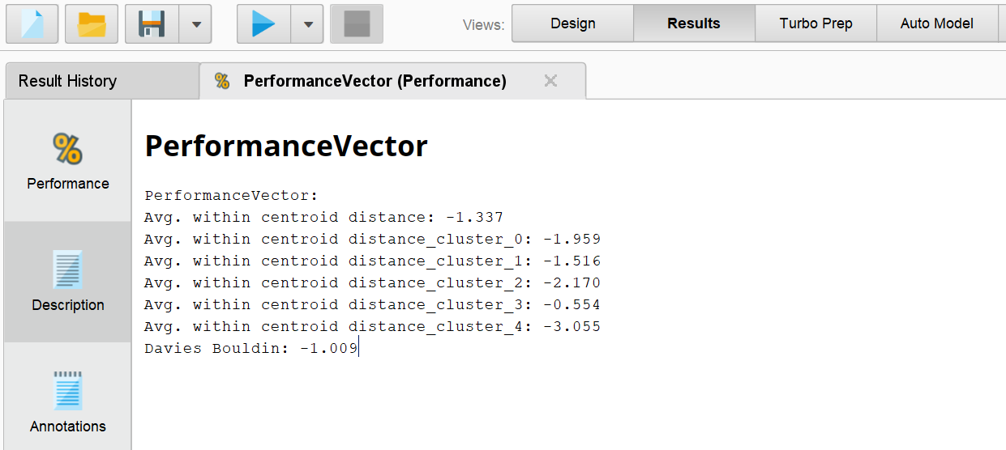
5.2 Quality Assessment: GOOD CLUSTERING
Criterion | Assessment | Evidence
Separation | Good | Davies-Bouldin = -1.009
Cohesion | Moderate | Avg distance = -1.337
Interpretability | Excellent | Clear risk progression
Actionability | Excellent | 46 critical-risk students identified
Stability | Good | No degenerate clusters (<30 students)
Limitations:
- Negative metric values indicate some cluster overlap
- Cluster 4 shows higher dispersion (heterogeneous high-risk group)
- Model should be re-validated with new semester data

PHASE 6: CLUSTER PROFILES (INTERPRETATION)
6.1 Cluster Centroids (Z-Scores)
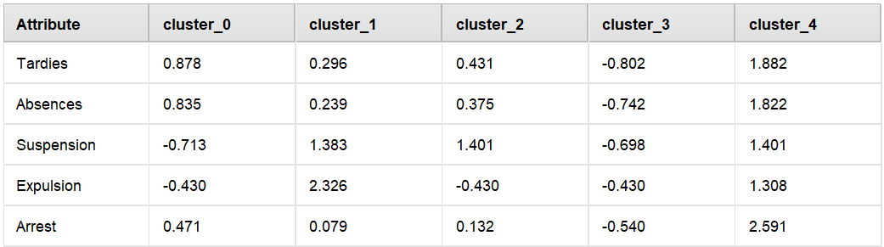
6.2 Risk Profile Interpretation
Cluster 3: LOW RISK (439 students, 46.6%)
- All risk factors below average (negative z-scores)
- No suspension or expulsion flags
- Lowest arrest rate
- Profile: Engaged students, regular attendance, no behavioral issues
Cluster 0: MODERATE RISK - ATTENDANCE ONLY (188 students, 19.9%)
- Above average tardies (z=0.878) and absences (z=0.835)
- Below average suspension (z=-0.713) and expulsion (z=-0.430)
- Slightly above average arrests (z=0.471)
- Profile: Attendance problems but no serious behavioral flags
Cluster 2: HIGH RISK - BEHAVIORAL (152 students, 16.1%)
- Elevated tardies (z=0.431) and absences (z=0.375)
- High suspension rate (z=1.401)
- No expulsion flag (z=-0.430)
- Profile: Suspension history with moderate attendance issues
Cluster 1: SEVERE RISK - EXPULSION (118 students, 12.5%)
- Very high expulsion flag (z=2.326 - extreme outlier)
- High suspension rate (z=1.383)
- Elevated tardies and absences
- Profile: History of expulsion, significant behavioral concerns
Cluster 4: CRITICAL RISK - MULTI-SYSTEM (46 students, 4.9%)
- Extreme tardies (z=1.882) and absences (z=1.822)
- High suspension rate (z=1.401)
- Positive expulsion flag (z=1.308)
- Highest arrest rate (z=2.591 - extreme outlier)
- Profile: Involved with all risk factors; requires immediate intervention
6.3 Risk Summary
Risk Level | Clusters | Students | Percentage
Low Risk | 3 | 439 | 46.6%
Moderate Risk | 0 | 188 | 19.9%
High Risk | 2 | 152 | 16.1%
Severe Risk | 1 | 118 | 12.5%
Critical Risk | 4 | 46 | 4.9%
Total at-risk students (Clusters 0,1,2,4): 504 students (53.4%)
Total requiring immediate intervention (Clusters 1 & 4): 164 students (17.4%)

PHASE 7: RECOMMENDATIONS
7.1 Tiered Intervention Framework
Based on cluster membership, the following tiered interventions are recommended:
TIER 1: CRITICAL RISK (Cluster 4 - 46 students, 4.9%)
Characteristics: Extreme values on ALL five risk factors; highest arrest rate
Action | Timeline | Responsible
Mandatory parent/guardian conference | Within 5 days | Principal/Counselor
Assign school counselor and behavior specialist | Within 5 days | Student Services
Develop formal Behavioral Intervention Plan (BIP) | Within 10 days | BIP Team
Daily check-in/check-out with trusted staff | Immediate | Assigned Mentor
Weekly multi-disciplinary team review | Weekly | Student Success Team
Connect with community mental health services | Within 14 days | School Psychologist
Referral to juvenile justice diversion program (if applicable) | As needed | SRO/Counselor
TIER 2: SEVERE RISK (Cluster 1 - 118 students, 12.5%)
Characteristics: Expulsion history + high suspension rates
Action | Timeline | Responsible
Parent conference (phone or in-person) | Within 10 days | Grade-level VP
Re-entry contract following expulsion | Immediate | Administration
Weekly counseling sessions | Ongoing | School Counselor
Behavior tracking card with daily feedback | Immediate | All Teachers
Bi-weekly progress reports to parents | Every 2 weeks | Homeroom Teacher
Restorative justice circle participation | Within 14 days | Restorative Justice Coordinator
TIER 3: HIGH RISK (Cluster 2 - 152 students, 16.1%)
Characteristics: Suspension history + attendance issues
Action | Timeline | Responsible
Suspension re-entry meeting | Upon return | Assistant Principal
Attendance contract (signed by student/parent) | Within 5 days | Attendance Officer
Mandatory after-school tutoring (2x weekly) | Immediate | Academic Support
Check-in with counselor every 2 weeks | Ongoing | School Counselor
Monthly attendance and behavior review | Monthly | Student Success Team
TIER 4: MODERATE RISK (Cluster 0 - 188 students, 19.9%)
Characteristics: Attendance issues only (no behavioral flags)
Action | Timeline | Responsible
Automated attendance alert system | Immediate | IT/Administration
Parent notification letter/call after 3 tardies | Per event | Attendance Office
Attendance improvement plan | Within 10 days | Homeroom Teacher
Positive attendance incentives program | Ongoing | Student Activities
Peer mentoring assignment | Within 14 days | Counseling Office
TIER 5: LOW RISK (Cluster 3 - 439 students, 46.6%)
Characteristics: All risk factors below average
Action | Timeline | Responsible
Continue current supports | Ongoing | All Staff
Recognition for positive attendance | Quarterly | Administration
Peer mentor opportunities (mentor at-risk students) | Ongoing | Counseling
Leadership program participation | As available | Student Activities
7.2 School-Wide Systemic Recommendations
Action | Description | Implementation Timeline
Early Warning System (EWS) | Automated alerts when students exceed thresholds (Tardies >5, Absences >3, Suspension=1) | Month 1
Quarterly Risk Reassessment | Re-run clustering each term to track movement between clusters | Every 10 weeks
Student Success Team | Multi-disciplinary team meeting weekly to review at-risk students | Week 1
Data Dashboard | Real-time visualization of risk clusters for administrators | Month 2
Staff Training | Trauma-informed practices for working with students in Clusters 1,2,4 | Month 1
Restorative Justice Program | Alternative to suspension for students in Clusters 1,2 | Month 2
Parent Engagement Initiative | Targeted outreach to families of students in Clusters 1 and 4 | Month 1
7.3 Monitoring and Evaluation Framework
Metric | Target | Frequency | Responsible
Reduction in Cluster 4 size | <3% of population | Quarterly | Principal
Movement from high to moderate risk | 20% of students | Semester | Student Success Team
Attendance improvement | 10% reduction in absences | Monthly | Attendance Officer
Suspension reduction | 25% decrease | Semester | Administration
Arrest rate decrease | 50% reduction for Cluster 4 | Yearly | SRO/Counseling

CONCLUSION
The K-means clustering analysis successfully identified five distinct risk profiles among 943 students. The model demonstrates good clustering quality with interpretable patterns and actionable insights. Key findings:
- 46 students (4.9%) require immediate multi-system intervention
- 164 students (17.4%) need intensive behavioral support
- 439 students (46.6%) maintain low-risk status and can serve as peer mentors
The tiered recommendations provide a clear pathway for the school to allocate resources efficiently, targeting the highest-needed students while maintaining preventive supports for moderate-risk groups. Quarterly re-assessment using this clustering model will allow the school to track intervention effectiveness and adjust strategies as needed.
Report Generated: May 2026
Analysis Tool: Altair Studio (RapidMiner)
Total Students Analyzed: 943

Appendix:
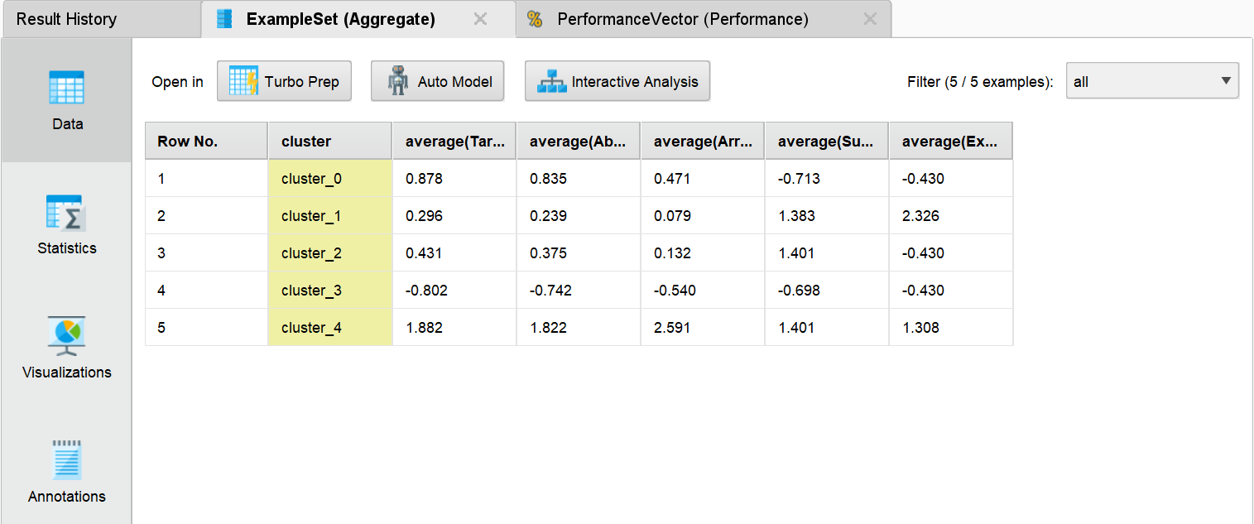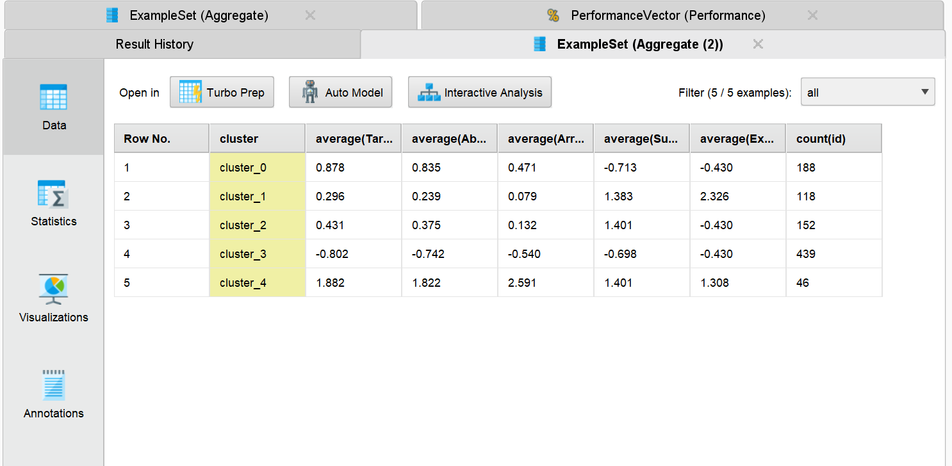
Chart 1: Cluster Size Distribution (Bar Chart)
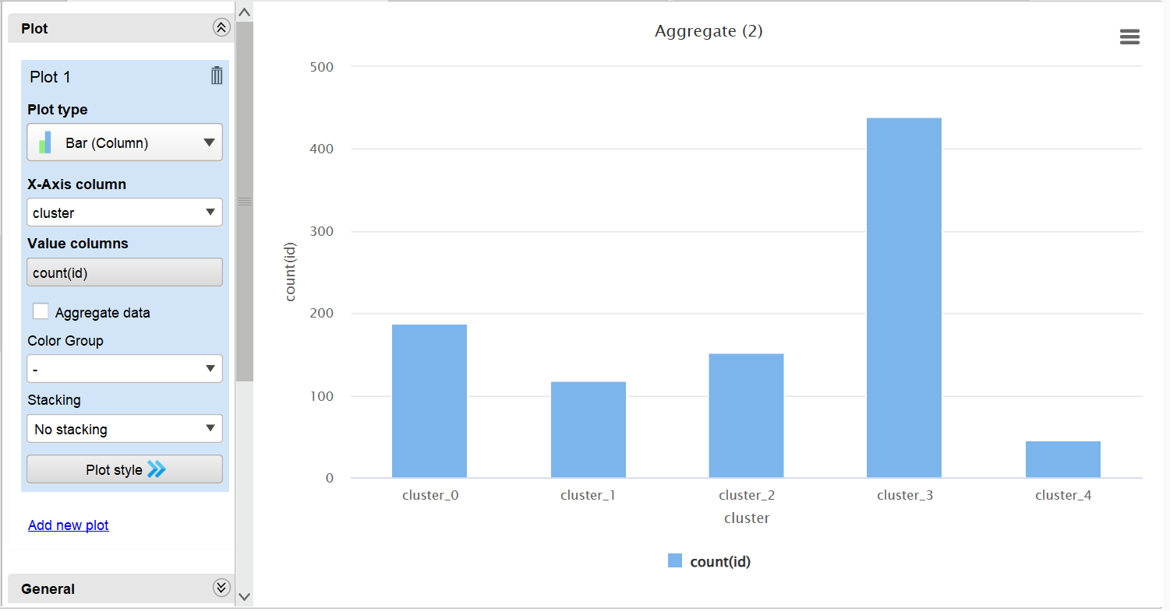
Chart 2: Risk Factor Heatmap
